In App models.py

from django.db import models

# Create your models here.

class Lists(models.Model):

    messages = models.TextField(max_length=500,null=True)

    added_at = models.DateTimeField(auto_now_add=True)

In app , admin.py, import and register the model

from django.contrib import admin

from .models import Lists

# Register your models here.

admin.site.register(Lists)

Start make makemigrations

(env) PS F:\python-django\todolist> python manage.py makemigrations

Migrations for 'list':

list\migrations\0001_initial.py

+ Create model Lists

(env) PS F:\python-django\todolist>

============================

Start the migrate

(env) PS F:\python-django\todolist> python manage.py migrate

Operations to perform:

Apply all migrations: admin, auth, contenttypes, list, sessions

Running migrations:

Applying list.0001_initial... OK

(env) PS F:\python-django\todolist>

In views.py

from django.shortcuts import render

# Create your views here.

def todolist(request):

    return render(request,'index.html')

create the templates folder , add html files

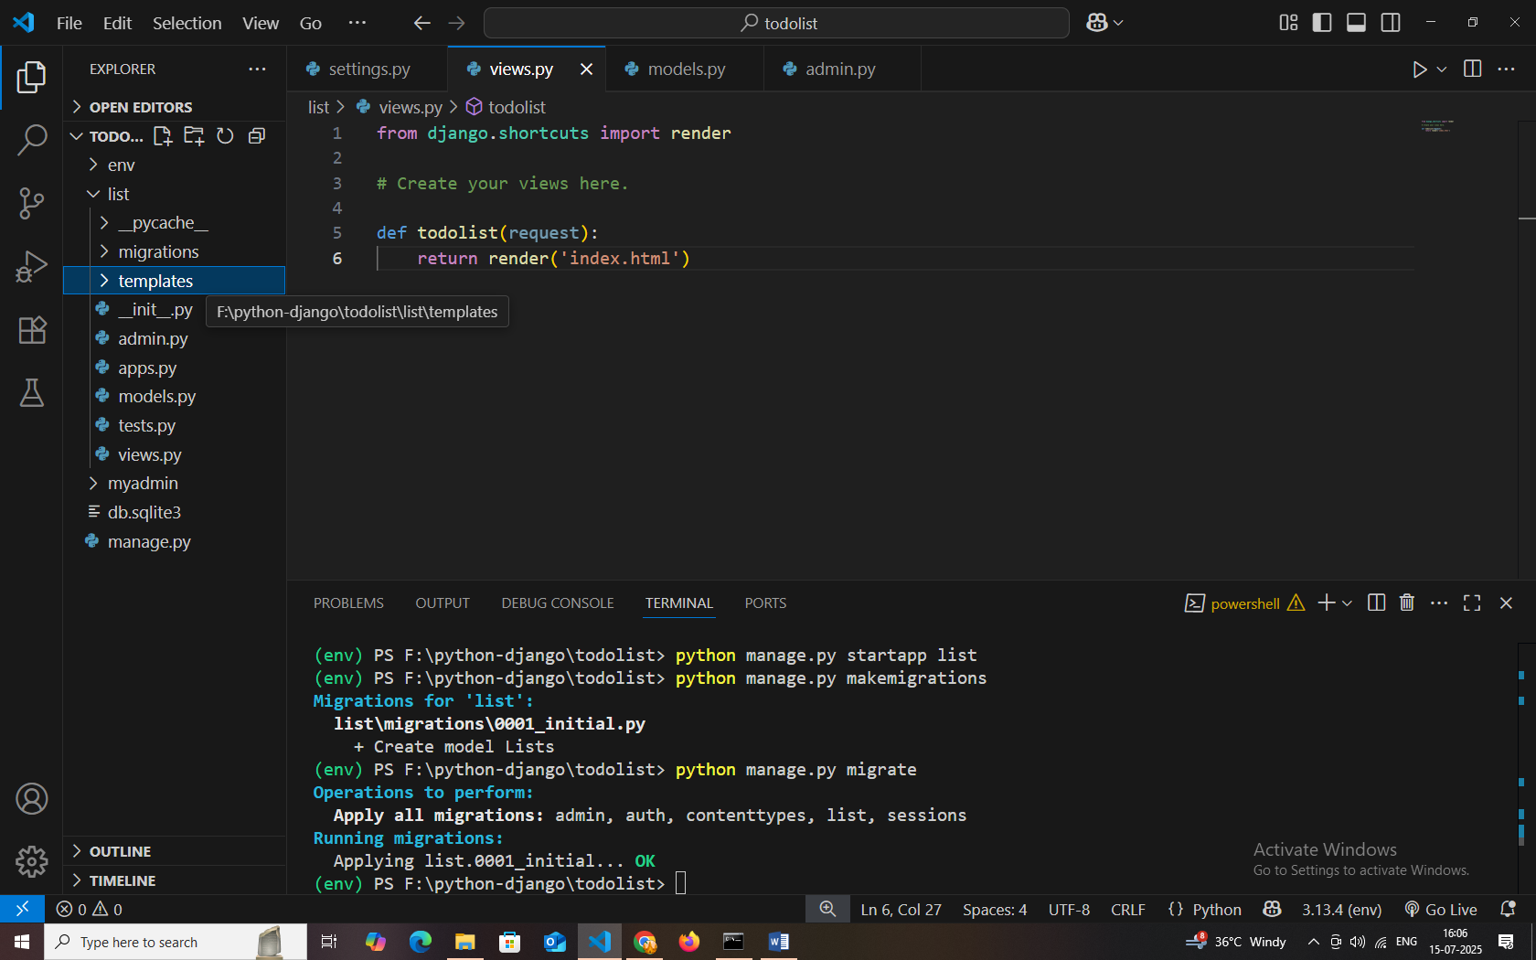

Once complete to add .html files then go to view and check it out.

Next, create the urls.py file in **current app**

from django.urls import path

from . import views

urlpatterns = [

    path("",views.todolist,name="todolist")

]

Next , register the current urls in **project** urls files

from django.contrib import admin

from django.urls import path , include

urlpatterns = [

    path('list/',include('list.urls')),

    path('admin/', admin.site.urls),

]

from django.shortcuts import redirect, render

from .models import Lists

# Create your views here.

def todolist(request):

    all_lists = Lists.objects.all()

    if all_lists:

        return render(request,'index.html',{'lists':all_lists})

    else:

        return render(request,'index.html')

def save(request):

    # print(request.method)

    if request.method == "POST":

       mes =  request.POST.get("messages")

       isSave = Lists.objects.create(messages=mes)

       isSave.save()

       return redirect('todolist')

from django.shortcuts import redirect, render

from .models import Lists

# Create your views here.

def todolist(request):

    all_lists = Lists.objects.all()

    if all_lists:

        return render(request,'index.html',{'lists':all_lists})

    else:

        return render(request,'index.html')

def save(request):

    # print(request.method)

    if request.method == "POST":

       mes =  request.POST.get("messages")

       isSave = Lists.objects.create(messages=mes)

       isSave.save()

       return redirect('todolist')

def delete(request,id):

    list = Lists.objects.get(id=id)

    list.delete()

    return redirect('todolist')

def update(request,id):

    list = Lists.objects.get(id=id)

    return render(request,'update.html',{'list':list})

def update_form(request,id):

    # print(request.method)

    list = Lists.objects.get(id=id)

    if request.method == "POST":

        mes =  request.POST.get("messages")

        list.messages = mes

        list.save()

        return redirect('todolist')

# let obj ={

#     "message":"hi",

#     "name":"siva"

# }

# console.log(obj.name)

# obj.name = "raja"